Apache OpenOffice VC-Plugin

1. Task Assigned

Instead of directly jumping into the nexpose code base, we are creating a plan with the hand's on experience which will help you to understand the nexpose architecture and other component's.
First will start with creating the VC-Plugins.
Create a VC Plugin:
- Pick the product which rapid7 has coverage.
- Find the products in here
Requirement:
- Get the data from the advisory page for the product which your team has selected and store it in your local machine. (.html and .json format acceptable)
- Transform that data into the Pydantic data object’s and validate the data.
- Transform the Pydantic data objects into 3 files (.xml, .vck, .sol) which are content files. Follow the rapid7 standard’s to generate the files.
- Load those files into the local storage under the folder of product name. Create the Content folder inside that creates the folder name of the product you picked.

This project is designed to provide hands-on experience in understanding the architecture and workflow of Rapid7 Nexpose by creating VC (Vulnerability Content) Plugins. The VC-Plugin workflow demonstrates the entire lifecycle of a vulnerability from advisory retrieval to VC content deployment.

2. Selected Product
Product: Apache OpenOffice
- Apache OpenOffice is an open-source office productivity suite.
- The project focuses on automating the process of generating Rapid7-compatible VC plugins for OpenOffice vulnerabilities.

3. Task Overview
The assigned task is to create a VC plugin for Apache OpenOffice following Rapid7 standards. The high-level objectives are:
- Pick the Product:
Select a product supported by Rapid7 (Apache OpenOffice).
- Fetch Advisory Data:
  - Retrieve vulnerability data from the official OpenOffice advisory page.
  - Store the advisory locally in HTML format.
- Parse & Store Data:
  - Extract individual CVEs from the HTML.
  - Save each CVE as a separate JSON file in a structured directory.
- Pydantic Validation:
  - Transform the raw JSON data into Pydantic data models.
  - Validate data for correctness and completeness (CVE ID format, affected versions, description, and source URL).
- Generate VC Content Files:
  - Transform validated CVE objects into three Rapid7 standard files:
    - .xml → vulnerability description
    - .sol → solution/fix recommendation
    - .vck → VC plugin entry per CVE
- Folder Structure & Storage:
  - Organize all content files under a Content/OpenOffice/CVEs directory.
  - Generate a product-level VCK file (product.vck) summarizing all CVEs.

4. Folder Structure
openoffice_vc_plugin/
├── fetch_openoffice_advisory.py
├── generate_vc_plugin.py
├── models/
│ └── cve.py
├── data/
│ ├── raw/
│ │ └── openoffice_advisory.html
│ └── parsed/
│ ├── openoffice_vulns.json
│ └── cves/
│ └── CVE-XXXX-YYYY.json
├── Content/
│ └── OpenOffice/
│ ├── CVEs/
│ │ ├── CVE-XXXX-YYYY.xml
│ │ ├── CVE-XXXX-YYYY.vck
│ │ └── CVE-XXXX-YYYY.sol
│ └── product.vck
├── requirements.txt

5. Workflow Overview
- Fetch OpenOffice Advisory Page:
  - fetch_openoffice_advisory.py retrieves the OpenOffice security bulletin HTML.
- Parse and Extract CVEs:
  - CVEs are parsed using BeautifulSoup.
  - Each CVE contains:
    - cve_id
    - affected_version
    - description
    - source_url
- Save CVEs as JSON:
  - Each CVE is stored as a separate JSON file.
  - File names are normalized for safe filesystem storage.
- Validate CVEs with Pydantic:
  - Ensures CVE IDs follow the correct pattern.
  - Ensures mandatory fields (description, affected_version) are present.
  - Skips invalid or incomplete CVEs to prevent content errors.
- Generate VC Plugin Content:
  - For each CVE JSON:
    - .xml → stores vulnerability metadata
    - .sol → provides solution/fix recommendation
    - .vck → contains a VC plugin entry for Nexpose
  - product.vck → summarizes all valid CVEs for the product
- Folder Structure Creation:
  - Script automatically creates required directories:
    - data/raw
    - data/parsed/cves
    - Content/OpenOffice/CVEs

6. In-Depth Code Review

6.1 fetch_openoffice_advisory.py
- Purpose: Fetch and parse advisory pages; save CVE JSONs.
- Key Features:
  - Requests advisory page using requests library.
  - Parses HTML using BeautifulSoup.
  - Extracts multiple CVEs from a single HTML list item.
  - Saves each CVE as a separate JSON file in data/parsed/cves.
  - Uses polite delays (sleep) to avoid overloading the server.
- Strengths:
  - Modular functions (fetch_advisory_index, parse_vulnerabilities, fetch_and_save_cve_json).
  - Handles multiple CVEs per HTML element.
  - Retry mechanism for failed HTTP requests.
- Validation: Prepares for Pydantic validation in the next step.
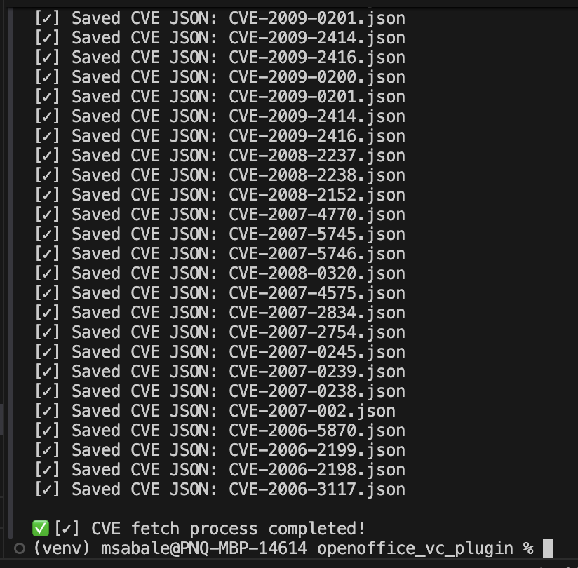

6.2 generate_vc_plugin.py
- Purpose: Transform CVE JSONs into Rapid7 VC plugin files.
- Key Features:
  - Pydantic CVE Model: Validates cve_id, affected_version, description, source_url.
  - Iterates over all CVE JSONs and generates:
    - .xml → vulnerability details
    - .sol → recommended solution
    - .vck → per-CVE plugin entry
  - Generates product.vck summarizing all valid CVEs.
- Strengths:
  - Strict validation ensures only accurate CVEs are included.
  - Fully automated folder creation and file writing.
  - Product-level summary (product.vck) allows Nexpose to load the plugin efficiently.
- Potential Improvements:
  - Add logging to track skipped/invalid CVEs.
  - Add optional CLI arguments for product selection or limiting number of CVEs.
  - Include caching to prevent re-fetching unchanged CVE data.
